How Earthquakes Work
By Tom Harris & Patrick Kiger

The earliest documented earthquake occurred in China in 1177 B.C. But for most of history, people didn't really have any idea what caused them -- though they had some wild theories, such as the belief earthquakes were caused by air rushing out of caverns deep in the Earth's interior. It wasn't until the mid-1800s that scientists began to study and measure earthquake activity in earnest, using a device developed in Italy called the seismograph. Finally, in the mid-1960s, researchers in the United States and Great Britain came up with a theory that explained why the Earth shook.

The theory, called plate tectonics, is that the Earth's crust, or lithosphere, comprises many plates that slide over a lubricating asthenosphere layer. At the boundaries between these huge plates of rock and soil, the plates sometimes move apart, and magma, or molten rock, comes to the surface, where it's called lava. It cools and forms new parts of the crust. The line where this happens is called a divergent plate boundary.

The plates also can push against each other. Sometimes, one of the plates will sink underneath the other into the hot layer of magma beneath it and partially melt. Other times, the edges of the two plates will push against each other and rise upward, forming mountains. This area is called a convergent plate boundary.
But in other instances, plates will slide by and brush against each other -- a little like drivers on the highway sideswiping each other, but very, very slowly. At the region between the two plates, called a transform boundary, pent-up energy builds in the rock. A fault line, a break in the Earth's crust where blocks of crust are moving in different directions, will form. Most, though not all, earthquakes happen along transform boundary fault lines.
There are four types of earthquake faults, which are differentiated by the relative position of the fault plane -- that is, the flat surface along which there's a slip during an earthquake.
In a normal fault, the fault plane is nearly vertical. The hanging wall, the block of rock positioned above the plane, pushes down across the footwall, which is the block of rock below the plane. The footwall, in turn, pushes up against the hanging wall. These faults occur where the crust is being pulled apart, at a divergent plate boundary.
The fault plane in a reverse fault is also nearly vertical, but the hanging wall pushes up, and the footwall pushes down. This sort of fault forms where a plate is being compressed. A thrust fault moves the same way as a reverse fault, but at an angle of 45 degrees or less. In these faults, which are also caused by compression, the rock of the hanging wall is actually pushed up on top of the footwall at a convergent plate boundary.
In a strike-slip fault, the blocks of rock move in opposite horizontal directions. These faults form when crust pieces slide along each other at a transform plate boundary. The San Andreas Fault in California is one example of a transform plate boundary.

With all these faults, rocks push together tightly, creating friction. If there's enough friction, they become locked, so that they won't slide anymore. Meanwhile, the Earth's forces continue to push against them, increasing the pressure and pent-up energy. If the pressure builds up enough, it will overcome the friction, the lock will give way suddenly, and the rocks will snap forward. To put it another way, as the tectonic forces push on the "locked" blocks, potential energy builds. When the plates are finally moved, this built-up energy becomes kinetic.
The sudden, intense shifts along already formed faults are the main sources of earthquakes. Most earthquakes occur around plate boundaries because this is where strain from plate movements is felt most intensely, creating fault zones, groups of interconnected faults. In a fault zone, the release of kinetic energy at one fault may increase the stress -- the potential energy -- in a nearby fault, leading to other earthquakes. That's one reason why several earthquakes may occur in an area in a short period of time.
These additional quakes are called foreshocks and aftershocks. The quake with the largest magnitude is called the mainshock; any quakes that occur before the mainshock are called foreshocks, and any quakes that occur after the mainshock are called aftershocks. Most of the time, the worst aftershocks occur within the first 24 hours after the mainshock hits. Bigger earthquakes trigger more aftershocks with larger magnitudes.

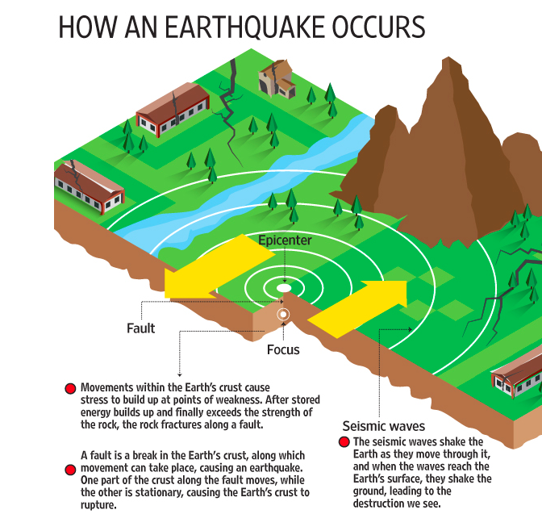

Why Do Earthquakes Happen?

Earthquakes are usually caused when rock underground suddenly breaks along a fault. This sudden release of energy causes the seismic waves that make the ground shake. When two blocks of rock or two plates are rubbing against each other, they stick a little. They don't just slide smoothly; the rocks catch on each other. The rocks are still pushing against each other, but not moving. After a while, the rocks break because of all the pressure that's built up. When the rocks break, the earthquake occurs. During the earthquake and afterward, the plates or blocks of rock start moving, and they continue to move until they get stuck again. The spot underground where the rock breaks is called the focus of the earthquake. The place right above the focus (on top of the ground) is called the epicenter of the earthquake.

Try this little experiment:
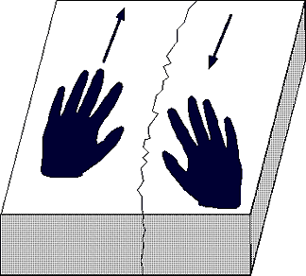
- Break a block of foam rubber in half.
- Put the pieces on a smooth table.
- Put the rough edges of the foam rubber pieces together.
- While pushing the two pieces together lightly, push one
piece away from you along the table top while pulling the
other piece toward you. See how they stick?
- Keep pushing and pulling smoothly.
- Soon a little bit of foam rubber along the crack (the fault)
will break and the two pieces will suddenly slip past each
other. That sudden breaking of the foam rubber is the
earthquake. That's just what happens along a strike-slip fault.

Earthquake-like seismic waves can also be caused by explosions underground. These explosions may be set off to break rock while making tunnels for roads, railroads, subways, or mines. These explosions, however, don't cause very strong seismic waves. You may not even feel them. Sometimes seismic waves occur when the roof or walls of a mine collapse. These can sometimes be felt by people near the mine. The largest underground explosions, from tests of nuclear warheads (bombs), can create seismic waves very much like large earthquakes. This fact has been exploited as a means to enforce the global nuclear test ban, because no nuclear warhead can be detonated on earth without producing such seismic waves.

The Birth of a Tsunami PREV NEXT
Formation of a tsunami
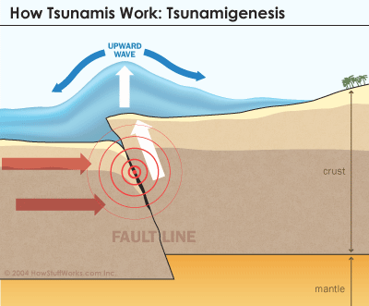
Underwater earthquakes are the most common tsunami instigator. To understand them, we have to delve into plate tectonics, which suggests that a series of huge plates makes up the lithosphere, or top layer of the Earth. These plates make up the continents and seafloor. They rest on an underlying viscous layer called the asthenosphere.
Think of a pie cut into eight slices. The piecrust would be the lithosphere and the hot, sticky pie filling underneath would be the asthenosphere. On the Earth, these plates are constantly in motion, moving along each other at a speed of 1 to 2 inches (2.5 to 5 centimeters) per year. The movement occurs most dramatically along fault lines (where the pie is cut). These motions can produce earthquakes and volcanism, which, when they occur at the bottom of the ocean, are two possible sources of tsunamis.

When two plates come into contact at a region known as a plate boundary, a heavier plate can slip under a lighter one. This is called subduction. Underwater subduction often leaves enormous "handprints" in the form of deep ocean trenches along the seafloor.
In some cases of subduction, part of the seafloor connected to the lighter plate may "snap up" suddenly due to pressure from the sinking plate. This results in an earthquake. The focus of the earthquake is the point within the Earth where the rupture first occurs, rocks break and the first seismic waves generate. The epicenter is the point on the seafloor (or other part of the Earth's surface) directly above the focus.
When this piece of the plate snaps up and sends tons of rock shooting upward with tremendous force, the energy of that force transfers to the water. The energy pushes the water upward above normal sea level. This is the birth of a tsunami. The earthquake that generated the Dec. 26, 2004, tsunami in the Indian Ocean had a magnitude of 9.1 -- one of the biggest in recorded history.
Once the water pushes upward, gravity acts on it, forcing the energy out horizontally along the surface of the water. It's sort of the same ripple effect you get from throwing a pebble in the water except the energy is generated by a force moving out of the water rather than into it. The energy then travels through the depths and away from the initial disturbance.
The tremendous force created by the seismic disturbance generates the tsunami's incredible speed. We calculate the actual speed of the tsunami by measuring the water depth at a point in time when the tsunami passes by.
A tsunami's ability to maintain speed is directly influenced by the depth of the water. A tsunami moves faster in deeper water and slower in shallower water. So unlike a normal wave, the driving energy of a tsunami moves through the water as opposed to on top of it. Therefore, as a tsunami moves though deep water at hundreds of miles an hour, it is barely noticeable above the waterline. A tsunami is typically no more than 3 feet (1 meter) high until it gets close to shore.
Once a tsunami gets close to shore, it takes its more recognizable and deadly form.
When a tsunami reaches land, it hits shallower water. The shallow water and coastal land acts to compress the energy traveling through the water. And the terrible transformation of the tsunami begins.
The topography of the seafloor and shape of the shore affects the tsunami's appearance and behavior. In addition, as the velocity of the wave diminishes, the wave height increases considerably. This compressed energy forces the water upward.
A typical tsunami approaching land will slow down to speeds around 30 miles (50 kilometers) per hour, and the wave heights can reach up to 100 feet (30 meters) above sea level. As the wave heights increase during this process, the wavelengths shorten considerably. Imagine squeezing an accordion and you get the general idea.
A witness on the beach will see a noticeable rise and fall of beach water when a tsunami is imminent. Sometimes, the coastal water will drain away completely as the tsunami approaches. This stunning sight is followed by the actual trough of the tsunami reaching shore.
Contrary to what you may have seen in Hollywood disaster films, tsunamis usually arrive as a series of swift, powerful floods of water, not as a single, enormous wave. However, a large vertical wave called a bore may come with a churning front. Rapid floods of water often follow bores, making them particularly destructive. Other waves can follow anywhere from five to 90 minutes after the initial strike. The tsunami wave train, after traveling as a series of waves over a long distance, crashes into the shore.
Tsunamis typically result in staggering body counts. This is especially true when they strike without warning. Tsunamis can level development and strip away coastlines, pulling everything in their path out to sea.

Seismic Waves

When you toss a pebble into a pond, it creates radiating waves in the water. An earthquake does the same thing with energy. When the plates fracture or slip, energy is released as seismic waves [source: USGS].
There are several types of seismic waves. Body waves move through the inside of the Earth. There are two types of body waves:
Primary waves (or P waves) are the fastest moving waves, traveling at 1 to 5 miles per second (1.6 to 8 kilometers per second). They can pass through solids, liquids and gases easily. As they travel through rock, the waves move tiny rock particles back and forth -- pushing them apart and then back together -- in line with the direction the wave is traveling. These waves typically arrive at the surface as an abrupt thud.
Secondary waves (also called shear waves, or S waves) are another type of body wave. They move a little more slowly than P waves, and can only pass through solids. As S waves move, they displace rock particles outward, pushing them perpendicular to the path of the waves. This results in the first period of rolling associated with earthquakes. Unlike P waves, S waves don't move straight through the Earth. They only travel through solid material, and so are stopped at the liquid layer in the Earth's core.
Unlike body waves, surface waves (also known as long waves, or simply L waves) move along the surface of the Earth. Surface waves are to blame for most of an earthquake's carnage. They move up and down the surface of the Earth, rocking the foundations of man-made structures. Surface waves are the slowest moving of all waves, which means they arrive the last. So the most intense shaking usually comes at the end of an earthquake.

Seismology

While the exact speed of primary waves (P waves) and secondary waves (S waves) varies depending on the composition of the material they're traveling through, the ratio between the speeds of the two waves will remain relatively constant in any earthquake. P waves generally travel 1.7 times faster than S waves [source: Stein].
Using this ratio, scientists can calculate the distance between any point on the Earth's surface and the earthquake's focus, the breaking point where the vibrations originated. They do this with a seismograph, a machine that registers the different waves. To find the distance between the seismograph and the focus, scientists also need to know the time the vibrations arrived. With this information, they simply note how much time passed between the arrival of both waves and then check a special chart that tells them the distance the waves must have traveled based on that delay.
If you gather this information from three or more points, you can determine the location of the focus through a process called trilateration. Basically, you draw an imaginary sphere around each seismograph location, with the point of measurement as the center and the measured distance (let's call it X) from that point to the focus as the radius. The surface of the circle describes all the points that are X miles away from the seismograph. The focus, then, must be somewhere along this sphere.
If you come up with two spheres, based on evidence from two different seismographs, you'll get a two-dimensional circle where they meet. Since the focus must be along the surface of both spheres, all of the possible focus points are located on the circle formed by the intersection of these two spheres. A third sphere will intersect only twice with this circle, giving you two possible focus points. And because the center of each sphere is on the Earth's surface, one of these possible points will be in the air, leaving only one logical focus location.
Besides determining the origin of the earthquake, scientists also want to measure its strength.

Richter Scale
Whenever a major earthquake is in the news, you'll probably hear about its Richter scale rating. You might also hear about its Mercalli Scale rating, though this isn't discussed as often. These two ratings describe the power of the earthquake from two different perspectives.
The most common standard of measurement for an earthquake is the Richter scale, developed in 1935 by Charles F. Richter of the California Institute of Technology. The Richter scale is used to rate the magnitude of an earthquake -- the amount of energy it released. This is calculated using information gathered by a seismograph.
The Richter scale is logarithmic, meaning that whole-number jumps indicate a tenfold increase. In this case, the increase is in wave amplitude. That is, the wave amplitude in a level 6 earthquake is 10 times greater than in a level 5 earthquake, and the amplitude increases 100 times between a level 7 earthquake and a level 9 earthquake. The amount of energy released increases 31.7 times between whole number values.
As we previously noted, most earthquakes are extremely small. A majority of quakes register less than 3 on the Richter scale; these tremors, called microquakes, aren't even felt by humans. Only a tiny portion -- 15 or so of the 1.4 million quakes that register above 2.0 -- register at 7 or above, which the threshold for a quake being considered major [source: USGS]. The biggest quake in recorded history was the 9.5 quake that struck Chile in 1960. It killed nearly 1,900 people and caused about $4 billion in damage in 2010 dollars [source: USGS]. Generally, you won't see much damage from earthquakes that register below 4 on the Richter scale.
Richter ratings only give you a rough idea of the actual impact of an earthquake, though. As we've seen, an earthquake's destructive power varies depending on the composition of the ground in an area and the design and placement of man-made structures. The extent of damage is rated on the Mercalli scale. Mercalli ratings, which are given as Roman numerals, are based on largely subjective interpretations. A low intensity earthquake, one in which only some people feel the vibration and there is no significant property damage, is rated as a II. The highest rating, a XII, is applied to earthquakes in which structures are destroyed, the ground is cracked and other natural disasters, such as landslides or tsunamis, are initiated.
Richter scale ratings are determined soon after an earthquake, once scientists can compare the data from different seismograph stations. Mercalli ratings, on the other hand, can't be determined until investigators have had time to talk to many eyewitnesses to find out what occurred during the earthquake. Once they have a good idea of the range of damage, they use the Mercalli criteria to decide on an appropriate rating.

Predicting Earthquakes

Today's scientists understand earthquakes a lot better than we did even 50 years ago, but they still can't match the quake-predicting prowess of the common toad (Bufo bufo), which can detect seismic activity days in advance of a quake. A 2010 study published in Journal of Zoology found that 96 percent of male toads in a population abandoned their breeding site five days before the earthquake that struck L'Aquila, Italy, in 2009, about 46 miles (74 kilometers) away. Researchers aren't quite sure how the toads do this, but it's believed that they can detect subtle signs, such as the release of gases and charged particles, that may occur before a quake [source: Science Daily].
Scientists can predict where major earthquakes are likely to occur, however, based on the movement of the plates in the Earth and the location of fault zones. They also can make general guesses about when earthquakes might occur in a certain area, by looking at the history of earthquakes in the region and detecting where pressure is building along fault lines. For example, if a region has experienced four magnitude 7 or larger quakes during the past 200 years, scientists would calculate the probability of another magnitude 7 quake occurring in the next 50 years at 50 percent. But these predictions may not turn out to be reliable because, when strain is released along one part of a fault system, it may actually increase strain on another part.
As a result, most earthquake predictions are vague at best. Scientists have had more success predicting aftershocks, additional quakes following an initial earthquake. These predictions are based on extensive research of aftershock patterns. Seismologists can make a good guess of how an earthquake originating along one fault will cause additional earthquakes in connected faults.
Another area of study is the relationship between magnetic and electrical charges in rock material and earthquakes. Some scientists have hypothesized that these electromagnetic fields change in a certain way just before an earthquake. Seismologists are also studying gas seepage and the tilting of the ground as warning signs of earthquakes. In 2009, for example, a technician at Italy's National Institute for Nuclear Physics claimed that he was able to predict the L'Aquila earthquake by measuring the radon gas seeping from the Earth's crust. His findings remain controversial.

How can scientists tell where the earthquake happened?
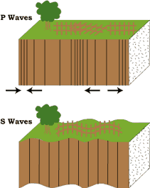
Seismograms come in handy for locating earthquakes too, and being able to see the P wave and the S wave is important. You learned how P & S waves each shake the ground in different ways as they travel through it. P waves are also faster than S waves, and this fact is what allows us to tell where an earthquake was. To understand how this works, let’s compare P and S waves to lightning and thunder. Light travels faster than sound, so during a thunderstorm you will first see the lightning and then you will hear the thunder. If you are close to the lightning, the thunder will boom right after the lightning, but if you are far away from the lightning, you can count several seconds before you hear the thunder. The further you are from the storm, the longer it will take between the lightning and the thunder.

P waves are like the lightning, and S waves are like the thunder. The P waves travel faster and shake the ground where you are first. Then the S waves follow and shake the ground also. If you are close to the earthquake, the P and S wave will come one right after the other, but if you are far away, there will be more time between the two. By looking at the amount of time between the P and S wave on a seismogram recorded on a seismograph, scientists can tell how far away the earthquake was from that location. However, they can’t tell in what direction from the seismograph the earthquake was, only how far away it was. If they draw a circle on a map around the station where the radius of the circle is the determined distance to the earthquake, they know the earthquake lies somewhere on the circle. But where?
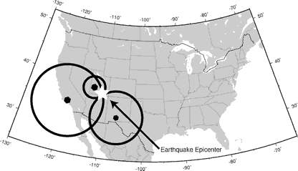
Scientists then use a method called triangulation to determine exactly where the earthquake was (figure 6). It is called triangulation because a triangle has three sides, and it takes three seismographs to locate an earthquake. If you draw a circle on a map around three different seismographs where the radius of each is the distance from that station to the earthquake, the intersection of those three circles is the epicenter!
Practice Problems:
- How far can an S-wave travel in 9 minutes?

- An earthquake occurs at 4:45:00 pm. When will the P-wave arrive at a location 4,000 km from the epicenter?

- A P-wave is detected at 3:30:00 pm by a seismogram located 2,000 km from the epicenter. When did the earthquake occur?

- A S wave is detected at 8:55:40 pm by a seismic station that is 3,000km from the epicenter. When did the earthquake occur?

- An epicenter station is 5,000 km away. How long after the first P-wave did the first S-wave arrive?

- A P-wave arrived at a seismic station 3,200 km away at 06:10:00. What time did the first S-wave arrive at this station?

- The first P-wave arrived at a seismic station at 10:00:00. The first S-wave arrived at the same seismic station at 10:08:40. How far is this seismic station from the epicenter?

