Name: _____________________________ Date: __________ Pd: ______

Unit 2 Formative Assessment – Plate Tectonics
Earthquakes
1. When an earthquake occurs, energy radiates in all directions from its source, called the ________.
A. Epicenter C. Fault
B. Focus D. Seismic center

2. A fault is ___________.
A. A place on Earth where earthquakes cannot occur.
B. A fracture in the Earth where movement has occurred.
C. The place on Earth’s surface where structures move during an earthquake.
D. Another name for an earthquake.
3. Identify AND describe the three (3) types of seismic waves:
A:

B:
C:
4. Describe how scientists find the epicenter of an earthquake.

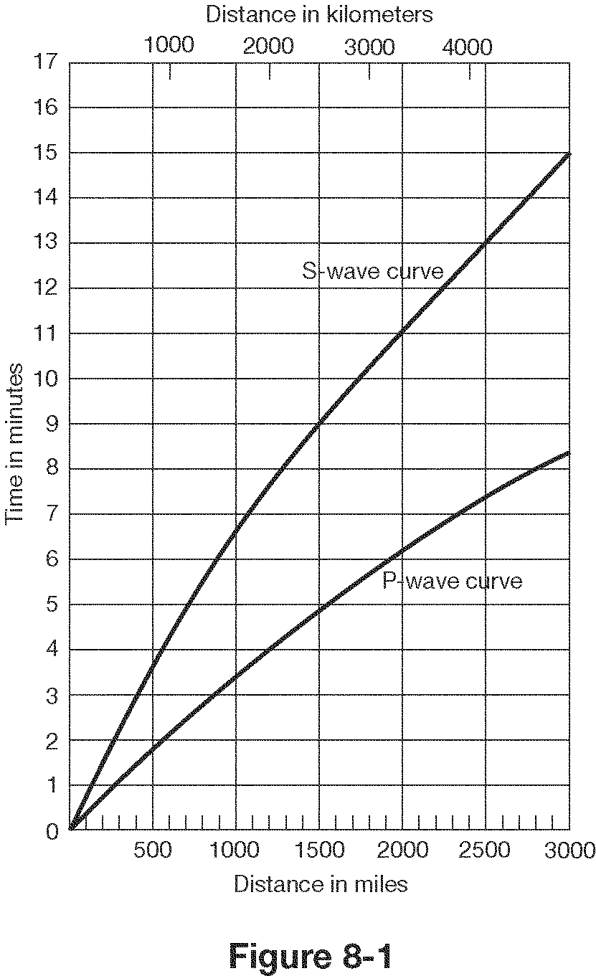

5. According to the figure to the right, what is the distance between the seismic station and an earthquake epicenter, if the first S wave arrives 5.0 minutes after the first P wave?

In miles: _______________

In Kilometers: _______________

Plate Tectonics
6. Who proposed the Continental Drift hypothesis AND what does it say?
- List four (4) pieces of evidence to support this hypothesis:
  - A.
  - B.
  - C.
  - D.
- What was the response of the scientific community to this hypothesis and why?
9. What is the weaker, hotter zone beneath the lithosphere that allows for motion of Earth’s rigid
outer shell?
A. Crust C. Asthenosphere
B. Outer Core D. Inner Core
10. Most of Earth’s earthquakes, volcanoes, and mountain building occur ______.
A. in the center of the continents. C. in the Himalayas.
B. at plate boundaries. D. at volcanic island arcs.

11. Match the left column with the right column by drawing arrows:
Convergent Boundary Grinding past each other
Divergent Boundary Moving together
Transform-fault Boundary Moving apart
12. Match the left column with the right column by drawing arrows:
Land Rift Valleys Divergent Oceanic-Oceanic
Continental Volcanic Arcs Convergent Oceanic-Oceanic
Mountains Convergent Oceanic-Continental
Volcanic Island Arcs Convergent Continental-Continental
Trenches Divergent Continental-Continental
Ocean Ridges Convergent Oceanic-Continental

13. Match the left column with the right column by drawing arrows:
Destructive Plate Margins Divergent Boundaries
Constructive Plate Margins Convergent Boundaries
14. Scientists agree that convection currents occurring in the _____ are the driving force for plate movement.
A. crust C. mantle
B. outer core D. inner core

15. The main source of heat in the Earth’s interior is due to _____.
A. the warm troposphere of our atmosphere C. the convection currents in the core
B. the eruption of volcanoes D. the radioactive decay of elements

16. __________ causes oceanic lithosphere to slide down the sides of the oceanic ridge due to
gravity.
A. Mantle plume C. Ridge-push
B. Convective flow D. Slab-pull

17. __________ is thought to be the primary downward arm of convective flow in the mantle.
A. Mantle plume C. Ridge-push
B. Convective flow D. Slab-pull

18. The _______ is a rigid outer layer of Earth that rests on top of a weak plastic layer of the mantle
called the _______.
A. asthenosphere, inner core C. lithosphere, asthenosphere
B. asthenosphere, lithosphere D. lithosphere, inner core
Volcanoes
19. Contrast lava and magma.

20. In what geographical region of the world are most volcanoes found? Why is this true?

21. Which of the following is NOT a type of pyroclastic material?
A. Lahar C. Lapilli
B. Cinders D. Volcanic bomb

22. Describe three (3) different types of pyroclastic material:
A:

B:

C:

Human Impact of Earthquakes and Volcanoes
23. Describe the necessary safety precautions and action responses of people living in regions with:
A: Earthquakes -

B: Volcanoes -

Geologic History of North Carolina
24. Describe how the Appalachian Mountains were formed (include the name of tectonic plates
involved and their motion).

25. What is the fall line in NC? Where is it found?

