Lab: Soil Quality & Texture Name: ______________________________ Pd: _____

Introduction: We live in an era of increasing concern over the conservation and management of our renewable and non-renewable resources. We seldom think of soil in these terms, and yet improper development or natural erosion can devastate a landscape that nature took centuries to create. Similarly, the mineral elements in the soil that nourish growing pants can be depleted through repeated cycles of cultivation and harvest, resulting in an exhausted soil incapable of supporting healthy plant growth.
For this lab exercise you are taking on the role of a soil scientist. Soil scientists receive samples of soil from individuals in the community and it is your role to analyze the soil sample that you have been given to make a recommendation to the homeowner about the quality of their soil and what they can do to improve the fertility of your soil. You will determine the quality of the soil through physical, chemical, and biological testing.

Physical Testing:

- 1. General Observations: Place a sample of soil onto a paper plate. What do you see?
    - A) Observe and give a description on the various particle sizes present.
    - B) Do any particle sizes dominate in abundance? If yes, identify.
    - C) What does the color of your soil indicate?
  - Soil Texture: Soil is made of mineral particles belonging to three size categories: clay, silt, and sand. The size of soil particles is important. Large particles of sand allow empty space for air and water to enter the soil. Smaller silt and clay particles help hold the water in a soil so that it does not drain away too quickly to be of use to plants. The ratios of these materials, or texture, can be determined qualitatively and quantitatively.
- 2. Soil Texture by Feel (Ribbon Test): Use a spoonful of your soil sample to perform the following experiment to determine the soil texture/type using the following flowchart. Then answer the following questions.
    - A) Determine what texture/type of soil you most likely have based on your results.
    - B) Outline or trace over the boxes/bubbles within the flowchart with a different colored marker/pen to show evidence of the path that you took to come to your final conclusion.

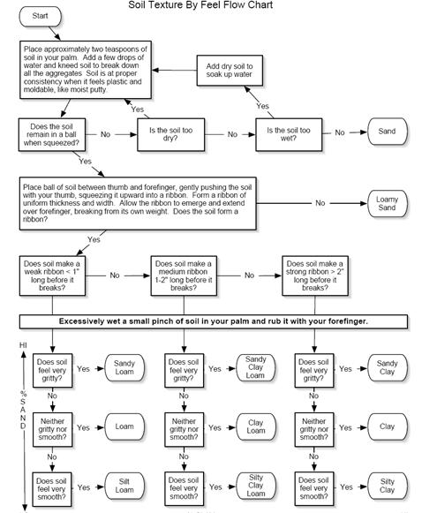

- 3. Soil Texture by Fractionalization: Sand has a larger particle size and so will settle out faster in a suspension (in water solution). Silt is the next in size so it settles out second with clay the smallest particle size and will settle on top.
  - 1. Break apart all clumps/chunks in your soil sample until all particles are loose.
  - 2. Fill a graduated cylinder with exactly 25mL of your soil sample.
  - 3. Add water to the graduated cylinder until the water volume reads exactly 75mL.
  - 4. Add 1mL (~10 drops) of ammonium hydroxide (household ammonia) into the graduated cylinder to separate the sand, silt, and clay.
  - 5. Cover the top of the graduated cylinder firmly with film paper. Place your hand over the excess film paper against the cylinder and invert several times until the soil is thoroughly suspended in the water.
  - 6. Set the cylinder aside and LEAVE IT undisturbed to fully settle out for at least 30 minutes.
  - 7. When the soil has completely settled out, there should be at least 3 distinct layers. Measure the volume (mL) of each layer and the total volume of soil for the sample (should be 25mL). Record your results in the data table below (INCLUDE UNITS IN EACH BOX)
  - 8. Calculate the percentage of each component in your soil in the data table below.
  - Fractionalization Data Table:
 | Volume (mL) |  | Percent (%)
Sand
Silt
Clay
 | Total Volume (mL):
    - A) Using the soil texture triangle and the calculated data above, what can you conclude as the type of your soil sample?
    - B) How does your answer compare to the soil texture type from using the qualitative test method (soil texture by feel)?
- 4. Soil Profile: Look at the layers of your soil profile (side-view) in the graduated cylinder.
    - A) Identify the layers/differences in color within your soil profile.
    - B) Sketch a picture of your soil profile (side-view) below AND color each visible layer. (Use a ruler to mark each layer within the soil profile)
Chemical Testing:

- 5. Fertility Analysis (pH test): There are several variables that are important in determining the fertility of soils. These include pH, amount of nitrogen, phosphorus, and potassium. The values of each component can serve as a limiting factor in the growth of plants. We will only use pH.

  - Use an electronic pH meter probe to determine the pH level of your sample. Make sure the pH meter sits flat on the counter to ensure an accurate reading of pH. Wipe clean the probe before using it on the next sample as to not cross-contaminate.
    - A) pH reading of your soil: ____________
Biological Testing:

- 6. Soil Biodiversity: It is important for soil to have a rich biodiversity of organisms working to decompose organic matter and aerate the soil. Soil health depends on the quantity of these organisms.
    - A) Do you see the presence of any (micro)organisms or plant material(s)? If yes, identify. If no, explain why you think this is true.

Analysis:

- How could you improve upon your soil type to make it more of a loam soil? What remediation(s) would be necessary?

- Assuming that your soil was also lacking in nutrients (N, K, and P), how would you go about remediating to make it suitable for plant growth?

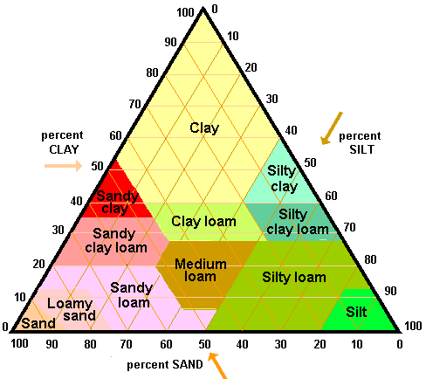
- Complete the soil triangle chart below:

 | % Sand | % Silt | % Clay | Soil Texture Name
1 | 75 | 10 | 15 | Sandy Loam
2 | 10 | 83
3 | 42 |  | 37
4 |  | 52 | 21
5 |  | 35 | 50

