Open Pit Mining

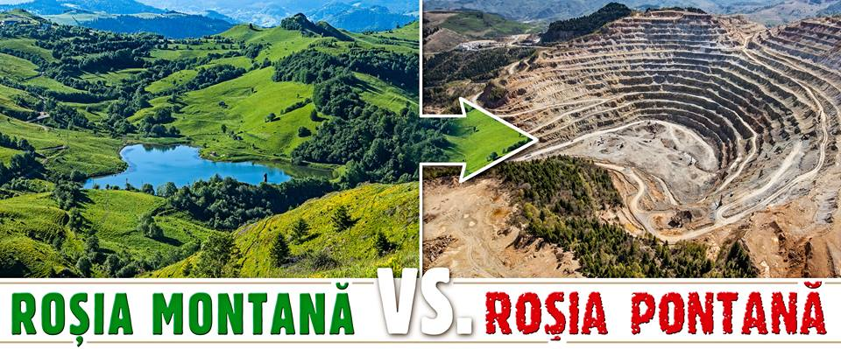
Type of surface mining where a large pit forms as ore is dug/exploded out and trucked away for the separation of valuable minerals.
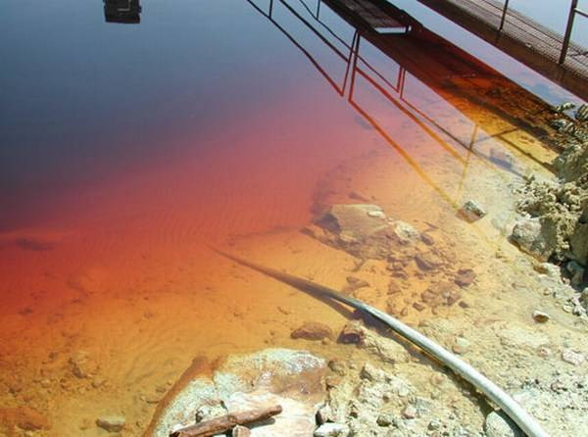
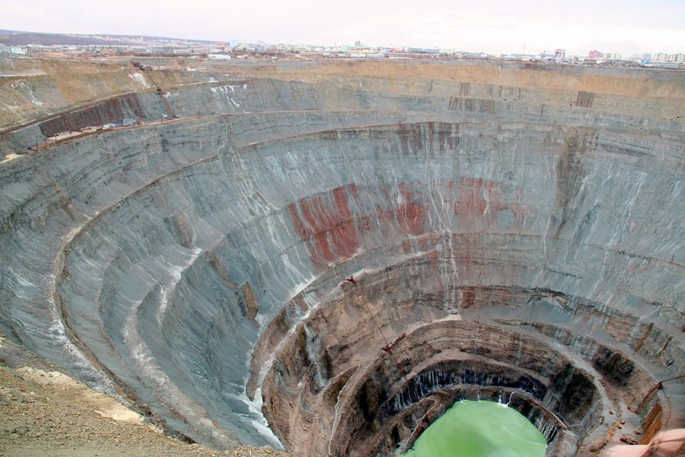
Strip Mining

Type of surface mining where ore is removed by machines moving in rows and trucked away while the tailings are deposited next to the path.

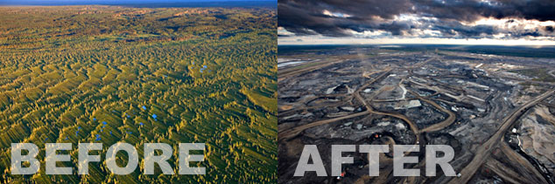

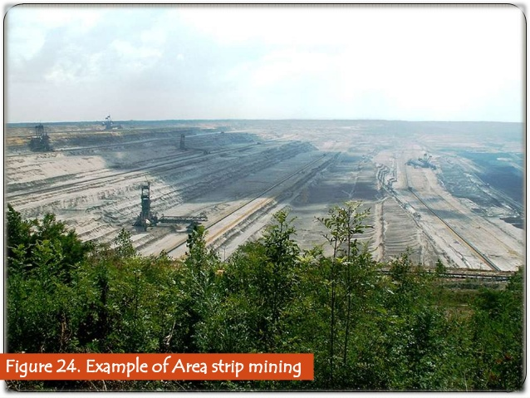

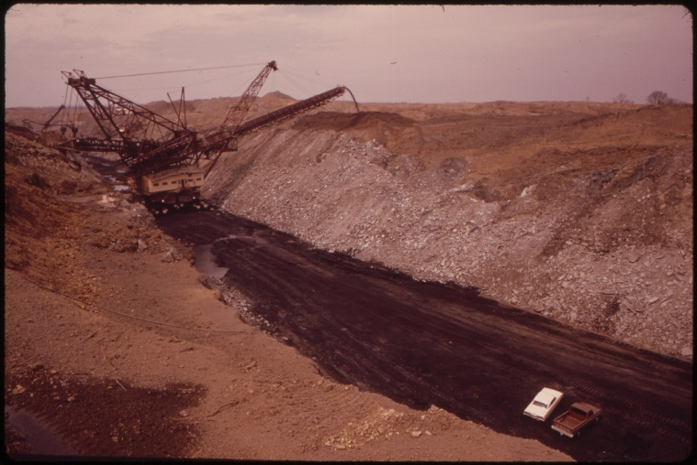
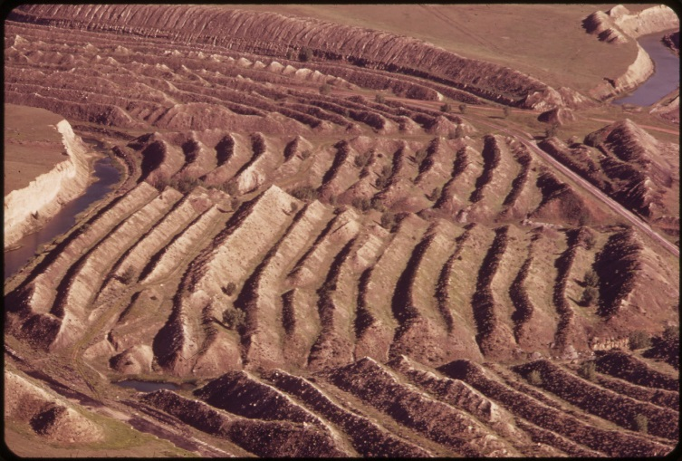

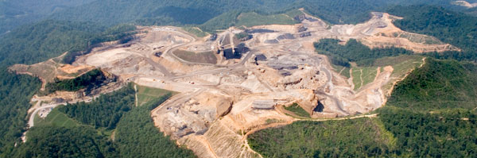
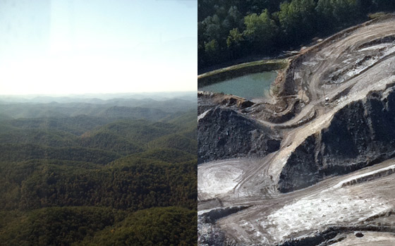
Type of surface mining where the top of a mountain is removed and ground up then trucked away to extract the minerals from the ore.
Mountaintop Removal Mining
Underground Mine Heavy Metals

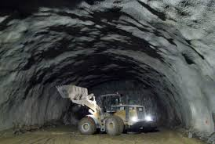
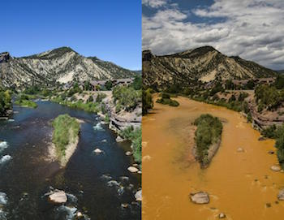
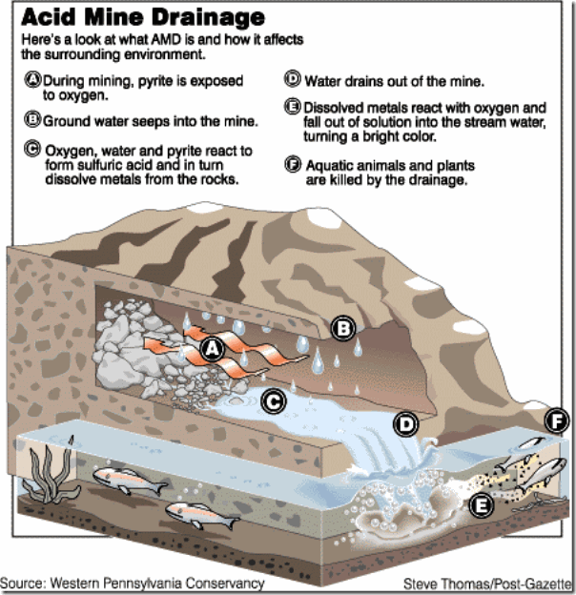
Type of subsurface mining where a tunnels are dug deep into the ground to remove the ore from within the Earth before trucking it away.

