MEDIA EVALUATION #9: Name:________________________
City vs. Country: Who Is Healthier? Urban Areas Clean Up, Residents Live Longer, Stay Fitter; But Stress Is Less in Rural Regions
By: Melinda Beck
Is city life killing you? Not necessarily. According to a recent report, you're more likely to get in a traffic accident, die of a gunshot wound, suffer from high blood pressure, obesity and diabetes if you live in a rural area. Melinda Beck explains.
For many urban dwellers, the country conjures up images of clean air, fresh food and physical activities. But these days, Americans residing in major cities live longer, healthier lives overall than their country cousins—a reversal from decades past.
Many cities that were once notorious for pollution, crime, crowding and infectious diseases have generally cleaned up, calmed down and spread out in recent years, while rural problems have festered. Rural residents are now more likely than other Americans to be obese, sedentary and smoke cigarettes. They also face higher rates of related health problems including diabetes, stroke, heart attacks and high blood pressure, according to County Health Rankings (CHR), a research project that recently issued its second annual report of state-by-state comparisons of health measures in every U.S. county.
To be sure, city dwellers live with more air pollution and violent crime. They also have higher rates of sexually transmitted diseases and low-birth-weight babies and are more likely to drink excessively. But overall, urbanites tend to rate their own health more highly and are less likely to die prematurely than rural Americans, according to the county rankings report.
In many measures, residents of suburban areas are the best off. They generally rate their own health the highest and have the fewest premature deaths than either their urban or rural counterparts. Suburbanites also have the fewest low-birth-weight babies, homicides and sexually transmitted diseases.
"Suburbs rule!" says CHR deputy director Bridget Booske, a senior scientist at the University of Wisconsin's Population Health Institute, which produces rankings with funding from the Robert Wood Johnson Foundation. 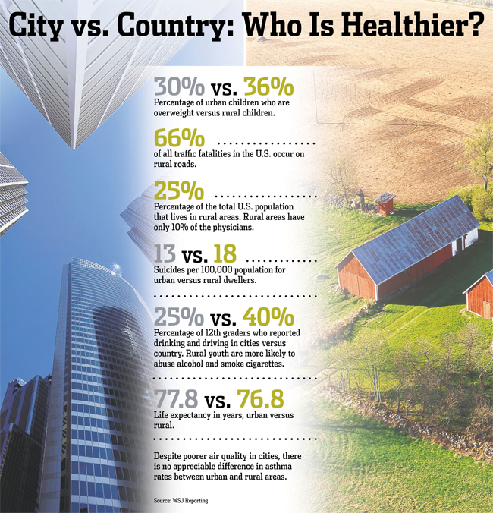
These broad generalities don't hold true for every region. For example, average life expectancy in the rural Northern Plains states—76 years for men and 82 for women—is four years greater than in Appalachia and Mississippi, according to a 2006 study from the Harvard School of Public Health. And life expectancy for white men in Washington, D.C., was 75 in 2007, but for black men it was 69, according to a new study by the University of Washington's Institute for Health Metrics.
Much of the health advantage in cities may be a function of age, income and education levels. The average annual household income in central cities is $53,000, according to the county ranking report. By contrast, average incomes are $39,000 in most rural areas and $60,000 in suburbs. Rural residents also tend to be older and less educated than their urban counterparts.
Limited access to care might help explain the overall poorer health of rural residents. About 25% of the U.S. population lives in rural areas, but they are served by only 10% of the country's physicians. They are also less likely to have private health insurance, prescription drug coverage or be covered by Medicaid, according to the nonprofit National Rural Health Association.
"Rural America is a place where those most in need of health-care services often have the fewest options," says Alan Morgan, the association's chief executive.
Unhealthy habits can start early. Rural children aged 2 to 5 are nearly twice as likely as urban kids to consume more than 24 ounces of sweetened beverages a day, according to a report last year from the South Carolina Health Research Center.
From age 6 to 11, rural kids consume on average 80 grams of fat a day, compared to 73 grams for urban children. Patterns of TV watching and physical inactivity are roughly similar between the two groups.
The nationwide problem with obesity hits rural areas hardest. Overall, 19% of rural children aged 2 to 19 are obese, and 36% of them are overweight, according to the center's report. By comparison, 15% of urban kids the same age are obese, and 30% are overweight.
Determining what areas are "urban" or "rural" can be murky. Some government agencies divide geographic areas into just two categories: metro and nonmetro, making it harder to identify trends in suburbs. Others use from six to 12 categories. Statistics are generally gathered and compared on a county basis, but many counties contain a mix of urban, suburban and rural areas.
A variety of conditions come together to make country living less healthy. For example, deaths from traffic accidents are more common in rural areas, not just because speed limits are higher, but also because the average emergency medical response to an accident is 18 minutes compared with 10 minutes in urban areas.
Of course, country living has some advantages. Children who grow up on farms tend to have less asthma and fewer allergies and autoimmune disorders than city kids. One theory for this holds that exposure to a variety of microorganisms helps build well-functioning immune systems, the so-called hygiene hypothesis.
It's long been observed that city dwellers have a higher rate of mental health problems than rural residents—39% more mood disorders and 21% more anxiety disorders, according to an analysis from 20 developed countries last year. The reasons aren't clear, but a study in the journal Nature this month, in which German researchers monitored the brain waves of urban and rural residents, suggests that people who grow up in cities may process stress differently.
People who move from a city environment to the country or vice versa generally bring their health habits with them. Leigh Young grew up on a tiny farm in rural Michigan, eating only what her family grew or slaughtered. Ms. Young, 55, now lives in urban Grand Rapids, where she says she isn't tempted by soda, chocolate or processed food. Her upbringing "made me far more aware of what I put into my body," she says.
Many places have their own health quirks. Matthew Joyce, 45, and his family moved from San Francisco to Boulder, Colo., 10 years ago. "It's so health conscious that if you don't participate you feel like the odd one out," he says. Farmers markets and health-food stores have squeezed out the doughnut shops, he says.
He and his family have become healthier, Mr. Joyce says. "We eat organic, exercise, meditate. But that doesn't mean you don't want a doughnut every now and again."
---------------------------------------------------------------------------------------------------------------------------------------

A Tale of Three Cities:
How a city and its surrounding suburbs and rural areas compared, health-wise.
 | NEW YORK CITY | NASSAU COUNTY (SUBURBAN) | SULLIVAN COUNTY (RURAL)
Premature death (years of potential life lost before age 75, per 100,000 population) | 5,197 | 4,483 | 8,477
Low-birth-weight babies | 8.4% | 7.7% | 7.9%
Adult obesity | 16% | 21% | 26%
Sexually transmitted infections (per 100,000 population) | 666 | 193 | 298

 | ST. LOUIS | ST. CHARLES COUNTY (SUBURBAN) | RIPLEY COUNTY (RURAL)
Premature death (years of potential life lost before age 75, per 100,000 population) | 6,778 | 5,436 | 16,025
Low-birth-weight babies | 8% | 6% | 10%
Adult obesity | 29% | 29% | 29%
Sexually transmitted infections (per 100,000 population) | 518 | 194 | 89

 | SAN FRANCISCO | CONTRA COSTA COUNTY (SUBURBAN) | LASSEN COUNTY (RURAL)
Premature death (years of potential life lost before age 75, per 100,000 population) | 5,793 | 5,544 | 7,949
Low-birth-weight babies | 7% | 7% | 7.9%
Adult obesity | 16% | 25% | 28%
Sexually transmitted infections (per 100,000 population) | 510 | 325 | 139

City or Country: Who is Healthier Media Evaluation
Answer the following in complete sentences on the back of this sheet or attach another sheet of paper. Do NOT answer next to/below the questions. In addition, you must highlight/underline and number the text to show where you found your information.

- Who lives longer, people in cities or their country cousins? Why?
- What problems are now more common in rural areas? Name at least five issues people in rural areas are more likely to face.
- List five issues that urban dwellers are more likely to have.
- What is the average life expectancy in rural Northern Plains?
- What percent of people live in rural areas? And what percent of doctors practice in rural areas? Why is this difference a problem?
- Copy and fill in the table:
 | Country (Rural) | City (Urban)
Kids 2-5: Amount of sweetened beverages consumed
Kids 6-11: Grams of fat consumed daily
Kids 6-11: Watching TV
Kids 2-19: obesity and overweight

- What two reasons cause traffic accidents to be more deadly in rural areas?
- Why do kids in rural areas have less asthma and fewer allergies than urban kids?
- Why do people in Boulder Colorado act healthy?
- Pick one city: New York, St. Louis, or San Francisco. Write at least three sentences to compare the health of people in these cities versus the people in the surround rural areas.

DO NOT WRITE IN THIS AREA!!!
Follow the instructions!

